Activity 5: Working with HTTP GET Request in PHP
Samantha Krall
CST-126

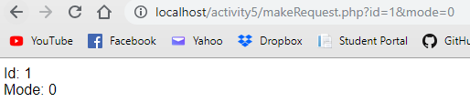
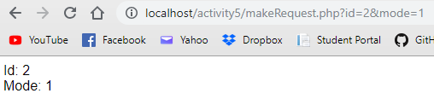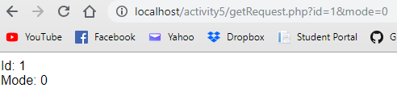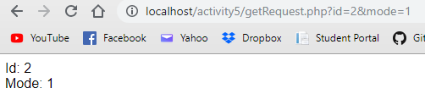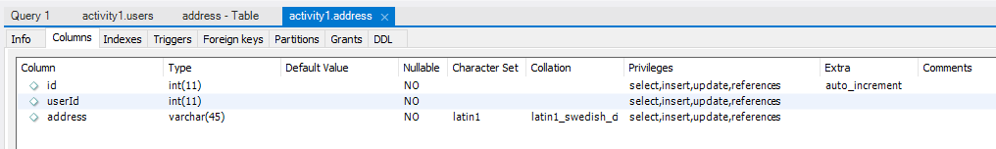
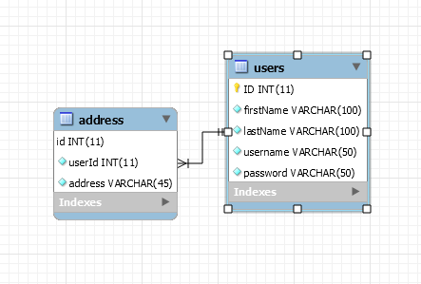

The first benefit of MySQL Workbench is the schema. I have started to understand why it is required to have the reverse and forward engineering for all the class projects. It allows for a neat packaging of all the information needed to use the same information. It is quite useful to use the reverse engineering to create an Entity Relationship Diagram. These have been required in previous classes, so I am familiar with them, so it is nice that workbench will save time by creating them for your databases.

